The Carbon Cycle

Why is carbon important?
- Carbon is the element which forms __________________________________________.
- Carbon can form long chain molecules, which include ___________________________ _______________________________________________________________________.
- Carbon is a _____________________________________________________________.

The Carbon Cycle
- Plants take in _______________________ because they need the carbon and oxygen to use in ____________________.
- Through ____________________ plants make ____________.
- When animals eat plants, they use some of the carbon containing compounds for __________.
- Some carbon containing compounds are used by organisms to ____________________ through the process of __________________.
- Carbon is released into the __________ in the ____________________________ of organisms, for example ___________, __________ and ___________________.
- These wastes are used as _________ by ___________________________________.
- Fossils are the ________________________________ of organisms.
- Coal and oil are ______________________, which contain the carbon of organisms that were preserved millions of years ago.
- Burning fossil fuels releases carbon that has been unavailable to the carbon cycle for millions of years.
- Burning _________ releases carbon stored for _____________________________.
- The earth’s ____________________________ store of carbon is the ______________________________ found in ___________________ (a rock usually formed from the shells of marine organisms).
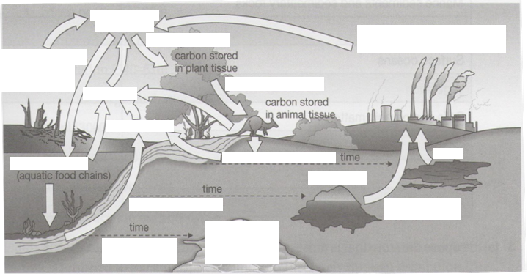

Questions:
- Name the process that takes carbon into food chains.
- Carbon is a major part of living things. Explain how the carbon gets into living things.

- Explain what the carbon is used for in the bodies of living things.

- Explain how decomposers return carbon to the atmosphere.

- Explain where the carbon in coal and oil came from.

- What is meant by the phrase long-term stores in relation to the carbon cycle?

- Name two stores of carbon.

